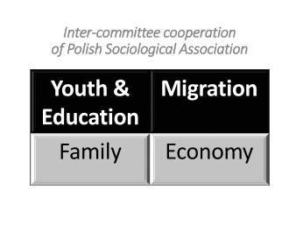
Online Inter-Committee Conference of the Polish Sociological Association
The social change in the 21st Century: Youth – Family -Economy – Migration
5-6 November 2020

CONFERENCE REGISTRATION FORM
Deadline for abstract submission: September 10th 2020
Conference fee: 100 pln

Title:
Name:
Surname:
Email:
[Optional: PTS Committee of the presenter]:

Presentation title:
Abstract (up to 500 words)

Data for Invoice (Institution, address)

Please send this conference form to: zmianaspoleczna.konferencja@gmail.com

Deadline for notifications of the abstract status: by the 25th of September 2020
Announcement of the conference program: the 30th of September 2020
Venue: Online

I give my consent for processing my personal data for the aims of organization of the conference “The social change of the 21st Century: Youth – Family -Economy – Migration” - pursuant to Article 13 of the Regulation of the European Parliament and of the Council (EU) of 27 April 2016 on the protection of individuals in regard of the processing of personal data and on the free movement of such data and the revocation of Directive 95/46/EC

