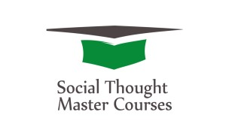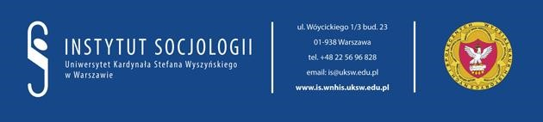

The 3rd Edition of
Social Thought Master Courses
March 29th 2017
International Scientific Seminar:
The Human Person in view of Contemporary
Civilisational Processes
and
March 30th 2017
International Scientific Conference:
Transformations of Contemporary Culture and their Social Consequences

Co-organizers:
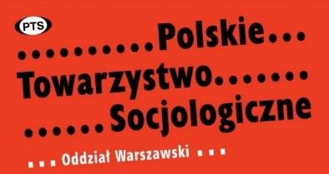

Honorary patronage:
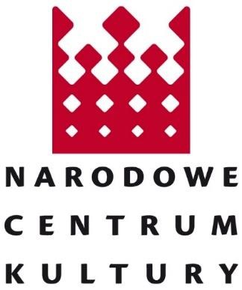

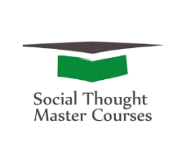
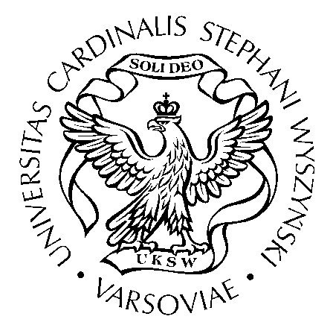
Cardinal Stefan Wyszyński University in Warsaw
Faculty Historical and Social Sciences
Institute of Sociology
Department of Social Thought

Organizer
Institute of Sociology, Cardinal Stefan Wyszyński University in Warsaw
Department of Social Thought
Unit of Research on Culture at the Department of Sociology of Religion

Co-organizers
Polish Sociological Association – Warsaw Department
Centre for the Thought of John Paul II
Faculty of Theology at the University of Silesia
Faculty of Social Sciences at the Warsaw University of Life Sciences – SGGW Sophia University Institute in Loppiano / Italy

The Scientific Committee
Prof. Margaret S. Archer – Pontifical Academy of Social Sciences
Prof. Bernhard Callebaut – Sophia University Institute in Loppiano, Italy
Ks. prof. zw. dr hab. Pavol Dancák, dr h.c. – University of Prešov in Prešov
Prof. Michele De Beni – Sophia University Institute w Loppiano
Ks. prof. zw. dr hab. Stanisław Dziekoński – Cardinal Stefan Wyszyński University in Warsaw
Ks. prof. dr hab. Stanisław Fel – The John Paul II Catholic University of Lublin
Prof. zw. dr hab. Zenon Gajdzica – University of Silesia in Katowice
Dr hab. Jarosław Horowski – Nicolaus Copernicus University in Toruń
Prof. dr hab. Arkadiusz Jabłoński – The John Paul II Catholic University of Lublin
Prof. dr hab. Dorota Kornas-Biela – Catholic University of Lublin
Dr hab. Marek Rembierz – University of Silesia in Katowice
Ks. prof. zw. dr hab. Henryk Skorowski – Cardinal Stefan Wyszyński University in Warsaw
Prof. zw. dr hab. Marek Szczepański – University of Silesia in Katowice
Prof. zw. dr hab. Bogusław Śliwerski, dr h.c. – University of Lodz
Prof. zw. dr hab. Wojciech Świątkiewicz – University of Silesia in Katowice
Dr hab. Maria Świątkiewicz-Mośny – Jagiellonian University in Kraków
Prof. dr hab. Krzysztof Wielecki – Cardinal Stefan Wyszyński University in Warsaw
Dr hab. Rafał Wiśniewski – Cardinal Stefan Wyszyński University in Warsaw
Dr hab. Joanna Wyleżałek – Warsaw University of Life Sciences – SGGW
Ks. prof. zw. dr hab. Sławomir Zaręba – Cardinal Stefan Wyszyński University in Warsaw
Dr Izabela Bukalska – Cardinal Stefan Wyszyński University in Warsaw
Dr Mariola Kozubek – University of Silesia in Katowice
Dr Klaudia Śledzińska – Cardinal Stefan Wyszyński University in Warsaw
Dr Katarzyna Wyrzykowska – Institute of Philosophy and Sociology Polish Academy of Sciences

Organizing Committee
Dr Klaudia Śledzińska – chair
Prof. dr hab. Krzysztof Wielecki – vice-chair
Mgr Agata Rozalska – secretary
Dr Izabela Bukalska
Dr Tomasz Korczyński
Mgr Katarzyna Drzewek
Mgr Joanna Kleszczewska
Mgr Anna Ksionek
Mgr Dorota Leonarska
Mgr Joanna Leszczyńska
Mgr Teresa Mazan

ul. Wóycickiego 1/3 bud. 23, 01-938 Warszawa tel. +48 22 569 68 28, is@uksw.edu.pl socialthoughtuksw@gmail.com

