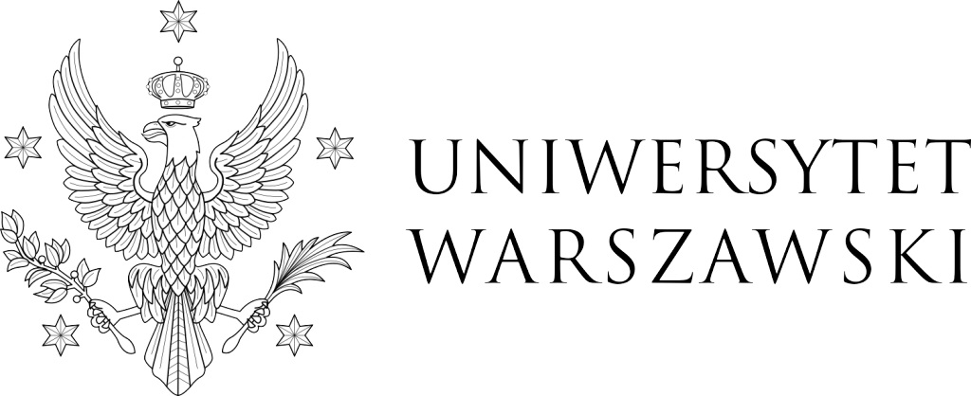
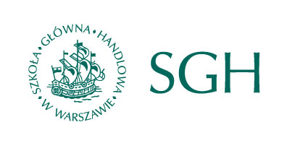
Call for papers
Industrial Relations in Europe Conference (IREC) 2017
Warsaw, 7-8 September 2017
co-organised by
Polish Sociological Association – Economic Sociology Section
Polish Sociological Association – Sociology of Work Section
Institute of Sociology, University of Warsaw
Faculty of Applied Social Sciences and Resocialisation, University of Warsaw
Institute of Philosophy, Sociology and Economic Sociology, Warsaw School of Economics

Industrial relations in Europe: between core and peripheries
Industrial relations in European countries are currently in the process of profound transformation that will have both long-term and short-term effects. The long-term trends, such as decentralization of collective bargaining, decreasing union density and erosion of corporatist institutions of social dialogue, have been further exacerbated by the impact of the global financial crisis, the resulting austerity measures and the emergence of new systems of European governance. In the face of multiple challenges, such as the expansion of precarious employment, increasing mobility of labour and capital, the weakening of welfare states and systems of social protection and the rise of digital economy, industrial relations actors’ capacities to represent their actual and potential members and to regulate employment relations have become increasingly limited.
In the context of the current economic and political crises of the European Union, it becomes necessary for our discipline to ask questions about the future of the European industrial relations. Are we now witnessing the expansion of illusory corporatism (which was previously said to be characteristic of Eastern European countries) also to the Western “core” countries? Alternatively, is the path-dependent development model of variegated industrial relations still valid, and therefore, do the current challenges simply reinforce the extant country vs. country, East vs. West, or core vs. periphery differences? Crucially, under which conditions can the current crisis be used as an opportunity to rethink and implement the high-road European model of industrial relations across the European Union countries? Can the crisis be used as a springboard for creating new solidarities and institutional coordination in Europe?
The Industrial Relation in Europe Conference in Warsaw in 2017 will aim to develop a critical understanding of the above-mentioned problems and challenges.

Prospective participants are asked to submit abstracts of max 400 words by 31 March 2017 via the submission form available at:
http://irec2017.uw.edu.pl/submission-form/

Paper proposals may be theoretical and/or empirical (using both/either qualitative or quantitative methods). As in the case of previous conferences, European comparative research papers are especially welcome. We invite paper proposals that will fit one of the 12 streams listed below:

- Theme 1: Developments in European industrial relations and beyond
- Theme 2: The future of the European Social Model
- Theme 3: Trends in collective bargaining and wage setting
- Theme 4: Employer organisations and business associations in Europe
- Theme 5: Transnational trade union cooperation
- Theme 6: Trade union revitalisation and non-union workers’ representation
- Theme 7: Changing employment and working conditions
- Theme 8: Labour market mobility and migration
- Theme 9: Industrial relations in Central and Eastern Europe
- Theme 10: HRM and union influence at company and workplace level
- Theme 11: Equality and diversity in industrial relations
Special stream: HR's role in managing disability in the workplace. Employment Relations Today

Authors of all proposals will be notified about the results of their abstracts’ evaluation by the members of Scientific Board and Organizing Committee by April 30th 2017.

Confirmed keynote speakers: Professor Richard Hyman (London School of Economics) and Professor Juliusz Gardawski (Warsaw School of Economics).

CONFERENCE FEES
- 30 EUR: unemployed
- 50 EUR: students, PhD students (early bird), 60 EUR: late registration
- 90 EUR: Full conference fee (early bird), 100 EUR: late registration

Conference fees covers organization and catering costs and conference dinner. It does not cover the costs of possible publications within the streams.

Deadline for payment: May 31st 2017 (early bird), July 31st 2017 (late registration). All registered participants will receive information about payment methods by the end of April 2017.

The reimbursement of conference fee in the event of cancellation by participant will be possible until July 31st 2017. Before this date, participants who need to cancel their attendance should send a notice of cancellation to the Organizing Committee, and they will receive reimbursement of the conference fee minus operational costs (bank transfer costs). No reimbursement will be possible after 31st July 2017.

WEBSITE & CONTACT
Further information on the streams and updates will be published on the conference website: irec2017.uw.edu.pl

SCIENTIFIC BOARD: Prof. Katharina Bluhm (Freie Universität Berlin), Dr Ercüment Celik (University of Freiburg), Prof. Juliusz Gardawski (Warsaw School of Economics), Prof. Richard Hyman (London School of Economics), Prof. Krystyna Janicka (University of Zielona Góra, Institute of Philosophy and Sociology of the Polish Academy of Sciences), Prof. Krzysztof Jasiecki (Institute of Philosophy and Sociology, Polish Academy of Sciences), Prof. Wiesława Kozek (University of Warsaw), Prof. Jolanta Kulpińska (University of Łódź), Prof. Bengt Larsson (University of Gothenburg), Dr hab. Adam Mrozowicki (University of Wrocław), Prof. Valeria Pulignano (Cathollic University of Leuven), Prof. Paul Stewart (University of Strathclyde).

ORGANISING COMMITTEE: dr Mikołaj Pawlak (chair), dr Jan Czarzasty, dr Joanna Róg-Ilnicka, dr Julia Kubisa, dr hab. Adam Mrozowicki, dr Piotr Ostrowski, dr Dominika Polkowska.

Contact: irec2017@uw.edu.pl

